Identifying Ships Using Satellite Images

Dr. Moturi Sireesha1, Tadavarthi Rukmini Gayathri2, Meda Asritha 3, Bandi Sai Harsha4 1 Professor, 2, 3 & 4 Student

[1nagatirumalarao@gmail.com,](mailto:cusb.atif@gmail.com) 2 [rukminigayathri3@gmail.com,](mailto:rukminigayathri3@gmail.com) 3 [meda.asritha@gmail.com,](mailto:meda.asritha@gmail.com) 4 [saiharshabandi90@gmail.com](mailto:saiharshabandi90@gmail.com) Department of Computer Science and Engineering,

Narasaraopeta Engineering College, Narasaraopet, Andhra Pradesh, India

**ABSTRACT**- When using remote sensing pictures for marine security, ship detection is essential. The deep learning method for identifying ships from satellite photos is covered in this research. In order to achieve integrity Hashing is included. This model makes use of a supervised method for classifying images, and then use YOLOv 3 for object recognition, feature extraction from Deep-CNN. Using class labels, semantic segmentation and picture segmentation are used to determine the object category of each pixel. Next, with the satellite image's bounding box is defined and helps us to identify the position of ship and ship count. We have implemented hashing with the help of SHA- 512. It is used to encode the Ship count and locations. A dataset of around 2,30,000 photos from Kaggle ship detection is used for the proposed model.

Thirty percent of the data is used for testing, while the remaining seventy percent is used for training. The bounding box location and the ship count are the input data used by the hash algorithm. In order to achieve security, we use SHA-512 which maintains security for the transmission of data.

**KEYWORDS**: Deep learning, detecting objects, YOLO v3; rel2bbox, SHA-512

## INTRODUCTION

When compared with machines, Humans can identify objects however they are placed irrespective of size, shape and color, while making machines to do same work requires a lot of energy and work. Identification of objects are found in many different fields, including machine learning, object tracking, picture retrieval, etc. Satellite images are usually made up of large no of pixels which ranges from centimeters to meters. These Images are in the form of water vapor, Infrared, Visible. In this Research Identifying ships is done with a model which gives high accuracy.

The advanced

YOLOv3 model was then trained and tested on the enlarged

dataset

The modern YOLOV3 can identifies objects dynamically like in images, videos. And it underwent trained and tested on large data set.

The YOLOV3 ML algorithm uses Deep CNN to detect objects located in the images. [12],[15]. Rel2bbox-The rel2bbox function is used to define the bounding boxes which helps us to spot the ships. It usually takes two parameters. The process is done pixel Co-ordinate, Width and Height respectively.

The figure1 depicts how yolov3 algorithm works and how various sizes of objects are identified. First the input is divided into 1x1 convolution layer later it is further divided into different layers these convolution layers are again down sampled and it also contains the ResNet which helps us to combine the layers for every input there is going to be three output predictions the first prediction defines the frame which is 19x19, second one is of 38x38 and third one is of 76x76.

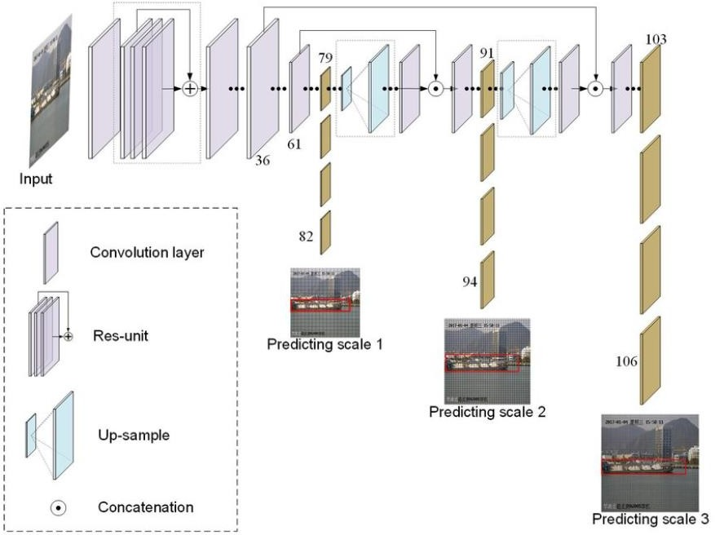

Fig 1: The frame work of YOLOV3 for Ship Identification.

Small objects are recognized at level 82 in the diagram above. Medium-sized objects are identified at level 94, while large-sized objects are detected at level 106.[1]

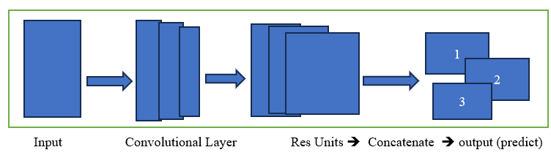

Fig 2: Process of how YOLOV3 detects objects in Images

In this model I have used Kaggle’s ship detection dataset which contains 2,30,000 photos out of which I have used 30% of images for evaluation and 70% of images are for trained. The dataset in Kaggle consists of mainly two parameters image Id and Encoded pixels. With which we can process the identification of ships in the satellite images. The dataset also includes cloud-covered photos, some of which just show land, some of which show fog, and some of which show no ships at all.

## LITERATURE SURVEY

The following are the references that are taken for reference for this research paper as a part of literature survey. From these manuscripts we are able to understand how an algorithm works and what algorithm needs to be used for the identification and structuring of bounding boxes.

Jeff Faudi et.al. [1] described a methodology where the identification of ships is done using one of the clustering algorithm K-Means. With the help of window- shielding method the input images which are large are broken down into small images. It can only identify one kind of ship. With the help of multilevel feature extraction, the accuracy increases as it helps to even detect small objects. The limitation is that (i) it cannot detect ship which are between sea and land (ii) if the image is too small then it will increase complexity. [11]

Nie, X. et.al [2] detected the ships using an attention mask for R-CNN and Segmentation analysis for the remote sensing. He has used a method which divides the pixel into two layers as bottom and top which leads to decrease the length and helps to increase the effective usage of bottom layers and by the usage of segmentation analysis, they can identify the objects by pixel by pixel and the disadvantage is that it only works for the identification of small objects.[7]

Van de Sande, K. E. et.al [3] used the segmentation for searching images. As we know that if we know the location of object then only, we can identify where the object is present in that image. Here he has used the segmentation to identify different locations of the object so that out of them the model can choose the best cluster from the group of locations.

The down side of this approach is that it only gives the accuracy for the images which are not clumsy. [8]

Hannevik, T. N. [4] implemented the utilization of SAR images from radarsat-2 which helps us to identify how the identification is done and the analysis, reporting of the images is combined. It has divided the ships into two categories like class A and class B, when compared with class B class A ships are easily identified and it is vulnerable – detection probability is based on the time rate of the signals, does not work well if the ships are in land masking. [9]

Redmon, J. et.al [5] implemented a model where the system works with the dpm and uses the window shield for the detection of objects. This method uses yolo to identify the images from a single convolutional layer from that the segmentation of the images is defined and with one look it can trace where the object is present and the imperfection is that it can provide security for the location identified by the model.[12]

Nie Xin et al. [6] described a model where the automatic ship detection and counting of ships will be done and with the help of yolo the process is designed by adjusting and optimizing the parameters. It can be done with the images which are HSV color histography and LBP target features the object detection and segmentation is done. The imperfection of this model is that it cannot overcome the overlapping of the ships and if they are similar and close to each other they can’t identify and differentiate it as two and also it does not work for the large data set and for video frames to.[17]

Zou, L. et.al [7] applied a model where the SAR images are generated and the detection is based upon the network of the images it proves that the multi class realistic images are generated from the Wasserstein distance and gradient penalty. The original SAR images are gradually expanded by using the generated sample images and the restriction for this model is that it cannot work best for different sea conditions, polarization modes and different incident angles. [10]

Tianwen Zhang et al. [8] implemented a model based on grid convolutional neural network for SAR images at high speed. G- CNN is an method proposed by him which is an combination of backbone CNN and detection CNN. First the image is converted to Grids for detection of objects and then the bcnn helps them to extract the features. It is done in three scales. The hurdle for this method is that it does not work well under dense images and only works for medium and high size images. [24]

## PROPOSEDSYSTEM

Our proposed system for identification of ships mainly consists of the following steps.

1. Dataset Preprocess
2. Bounding Boxes
3. Normalization
4. Ship Count
5. Bounding Boxes.
6. Hashing Value.
7. Images with No. of Ships, Bounding

boxes and Hashing Value.

**Dataset Preprocessing** –

The first step is to load the data set which is Kaggle air bus ship detection and analyze the data set. With the help of pandas library, we have read the data set in which we came to know that the data set consists of 2 columns namely Image Id and Encoded Pixels. After that data preprocess has been carried out. Dropping of null values with dropna function, by the help of aggregate function the no. of ships presents in the data set file that is in csv is calculated and Identification of unique images to improve accuracy and efficiency. Like if the image id has nor encoded pixel value, then it does not have ships in them and one Image Id has multiple rows of encoded pixel values then there are multiple ships in them.

**Defining Bounding Boxes –**

The second step is to define the bounding boxes the bounding boxes can be defined by the help of rel2bbox function which takes two parameters those are rel and shape and it returns four values which are X co- ordinate, Y co-ordinate which defines the shape of the box, Width, Height, the four values describe the locations from where to where and at which axis and up to what level or height, by that we can detect the area where the ship is located, and it is usually a shown by a rectangle box.

**Normalization –**

The third step is to Normalize and drop - encode the bounding boxes. After defining the bounding boxes now we need to standardize the encoded pixels and form the bounding boxes for the images which are normalized with the help of dropna function from pandas we will remove the encoded pixels which has no bounding boxes the normalization is done based on the Boolean value if the value is 0 or false then that pixel is going to be dropped.

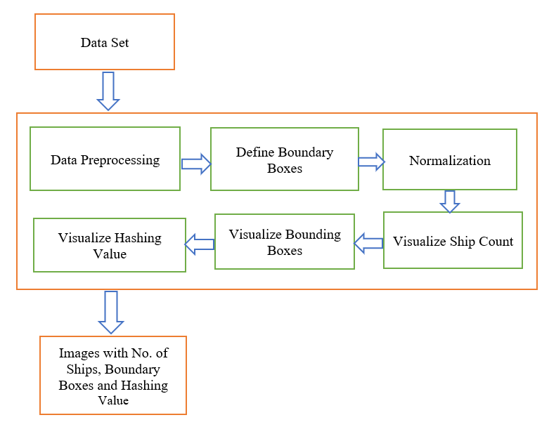

Fig 3: Proposed Methodology Architecture

Now we need find the find the area of the bounding boxes so that the area which is less than 1 percentile is removed and with the help of this we will able to identify the majority of ships size.

From the data set which we have usen shows us that the majority of the ships are in small size and a few of the ships are in medium with which we can know that the data set is highly imbalance. With the help of this from an input of 1000 images for training only 800 images are available for training the algorithm.

**Visualize Ship Count–**

The fourth step involves the visualization of the count of ships this is carried out as, first let us take a variable as count at first it is initialized to 0 and if the image has bounding boxes, then the count is going to be incremented by one and cross filter is going to be applied in order to protect the integrity of the algorithm. With the help of format specifier, the count of the ships is going to be visualized on top of the images.

**Visualizing Bounding Boxes -**

The fifth step is to visualize the bounding boxes as we have already defined the bounding boxes now the function is going to be called and with the help of encoded pixel values the bounding box is going to be drawn and with the help of this, we will be able to identify the ships.

**Visualizing Hashing Values -**

The sixth step involves the hashing of the location of ships along with the count of ships. In order to provide the encoded value to these we have used SHA-512 function from the hash library. And it uses 512 bits and these are divided into 64 bytes and this encoded algorithm is difficult to hack and usually takes 2256 times for the brute force approach [24].

The final output consists of the image which shows the number of ships at the top of it and a rectangle box around the ships and an encoded hash value which is displayed on the top of image below the count of ships.

The below algorithm depicts how the entire process is going to be happen for the identification of the ship

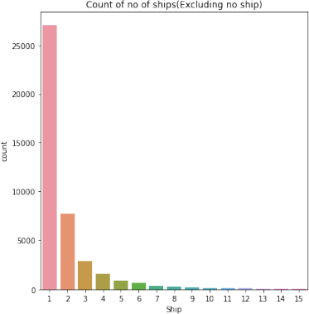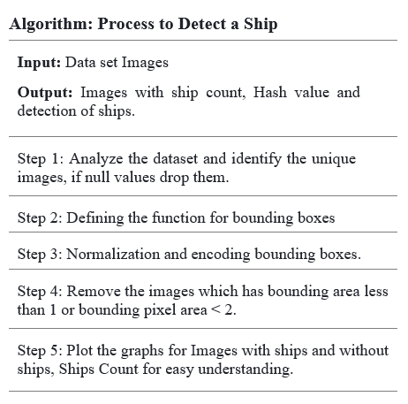

The information on the ratio of the datasets with and without ships, as well as the number of ships in each image, is now shown in detail in the following figures. Another figure shows the number of images with at least one ship in them.

The following figure shows the ratio of images which has ships to the images which don’t have images in the total data set. We have classified them with the help of unique and group by functions.

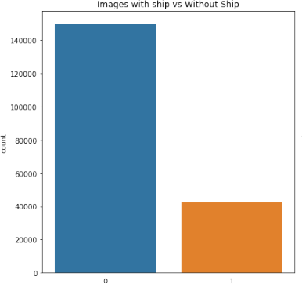

Fig 4: Images with Ship VS Without Ship

Now we have identified how many ships are there in a image. Like the no. of images with 0 ships and the no. of images with 1 ship etc..

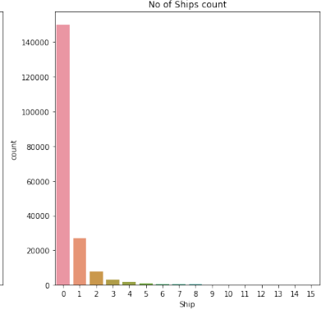

Fig 5: No. of Ships in an Image

The Fig.6 shows the images that have at least one image. Here we have tried to find out whether satellite images have at least one image. If there is no image then we are trying to remove the data of images which don’t have ships in them so that data gets simplified.

Fig 6: Images that have at least one ship.

# Performance Analysis:

The data set from the Kaggle which consists of 2,30,000 images which is used as per the below table,

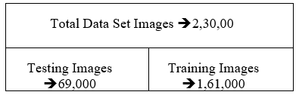

We have used the Confusion Matrix and Accuracy as the primary metrics to assess the model's performance. In addition, we have attempted to contrast our suggested approach with several techniques such as R-CNN and K-Means

Most researchers focus on the ship detection in

synthetic aperture radar (S

# Confusion Matrix:

Confusion matrix helps us to understand how well our model performs on the data set. It is used to show the number of correct and incorrect predictions done by the model based on actual outcomes.

It is primarily made up of four distinct components:

True-Positives: are instances in which the model accurately forecasts a positive class, such as when the ship is present and detected.

True-Negatives: when the model accurately forecasts a negative class in the absence of the ship

False-Positives: These occur when the model forecasts the positive class inaccurately, even when the ship is actually present.

False-Negatives: When the ship is absent while the model predicts it to be present, this leads to an inaccurate negative class prediction.

|  |  |  |
| --- | --- | --- |
|  | Predict Ship | Predict No Ship |
| Actual Ship | True Positive (97.8 %) | False Negative (3.5%) |
| Actual No Ship | False Positive (2.3%) | True Negative (95.7 %) |

Table 2 – Confusion Matrix

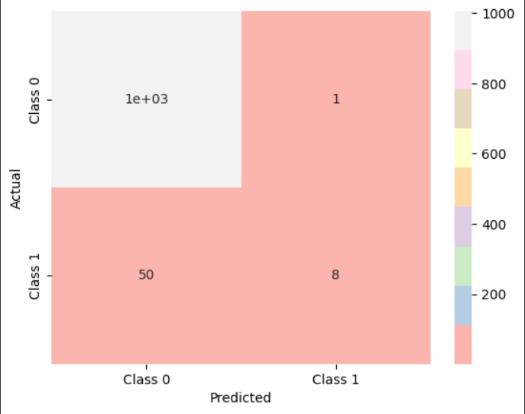

Fig 7: Confusion Matrix for the dataset

In the above figure Class 0 describes Negative and Class 1 describes Positive.

The confusion matrix also helps us to calculate accuracy, precision, F1-Score. The developed model performs well and identifies the ships under cloud and sand masking.

Tests have been carried out to evaluate the proposed model against other alternative strategies that are employed on training models with just well-defined images and testing models with preprocessed images. The findings revealed that, depending on the situation, our model could perform better at detecting.

While building this model we have also compared with other approaches like R-CNN and K-means in means of accuracy, precision, F1-Score, Recall out which if R-CNN gives an overall accuracy of 89% and K-Means gives 92% while the proposed method using YOLOV3 has given an highest accuracy of 97% in identifying ships from satellite images as it is going to detect the objects in three levels. The fig-8 depicts the comparison of these approaches, [6]

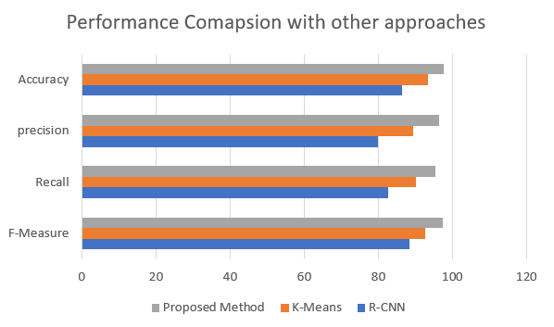

Fig8: Performance Comparison with other approaches.

# Accuracy:

One frequent statistic used to assess a machine learning algorithm's performance is accuracy. The ratio of accurately categorized instances to all instances in the test dataset is measured. From the confusion matrix when can calculate the accuracy it can be done by the formula of sum of true-positive (NTP) and true-negative (NTN) divided by sum of true-positive (NTP), true-negative (NTN), false-positive (NFP) and false-negative (NFN).

Accuracy = (NTP+NTN)

--------------------- (i)

(NTP+NTN+NFP+NFN)

The proposed model produces an accuracy of around 97.5 percent. Which states that out of 100 sample 97 samples are going to be predicted correctly.

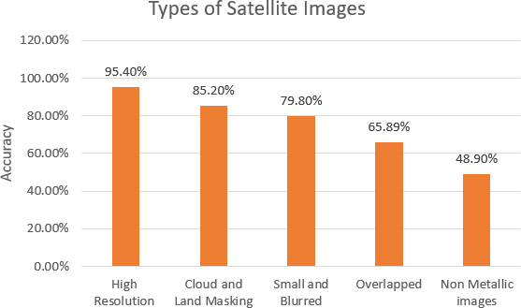

Fig9: Accuracy of prediction of different types of images.

**Recall:**

Recall usually know as sensitivity. It is the measure of correctly identifying the true-positives, or predicting correctly from the true-positive cases. It can be done as,

Recall = NTP

-------------- (ii)

(NTP+NFN)

## Precision:

Precision states that out of all the positive identification what are actually correct or at what level of the data that is predicted to be positive are actually positive. It can be evaluated by the formula,

Precision = NTP

-------------- (iii)

(NTP+NFP)

## F1Score:

Its primary application is model comparison. F1Score makes use of both precision and recall. Harmonic mean is taken into account rather than arithmetic mean. Assuming that R represents recall and P represents precision, the formula below can be used to determine the F1Score:

F1Score = (2*R*P)

-------------- (iv)

(R+P)

The performance of the suggested model is shown in the diagram below when compared to other models. It provides high accuracy and operates effectively when a sizable data set is provided as an input to the algorithm.

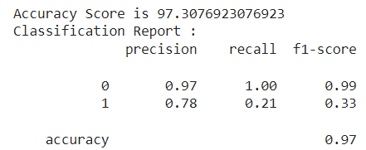

Fig 10: Performance of the model.

# Results:

Based on the satellite pictures, the proposed model recognizes the ships. The following describes the algorithm's workings and identifies, the hashing value and the number of ships will be provided if there are any ships in the image. There won't be a hashing value if the image is devoid of ships.

Fig.11 describes the scenario 1, the satellite image does not have any ships in them, so the output is displayed as below, there are 0 ships so count function displays the value of 0. As there is no ship that’s why the hashing does not work.

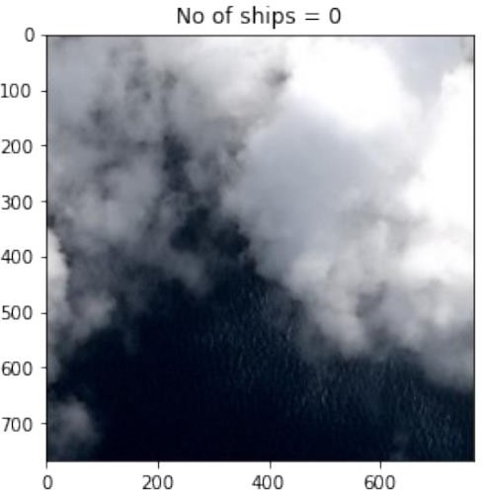

Fig 11: No ships in the satellite image.

Fig:12 describes the Scenario 2: how the algorithm detects the ship, first the encoded pixel values are going to be taken as input for the rel2bbox function along with the shape of the image which we want as an output the function returns the value of X-axis, Y-axis, breadth and height with the bounding box is going to be drawn on the image which helps us to spot the ship on the image.

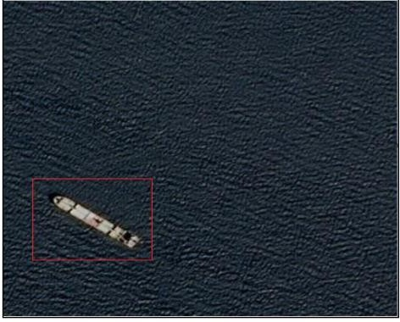Fig 12: Detection of ship from the satellite image.

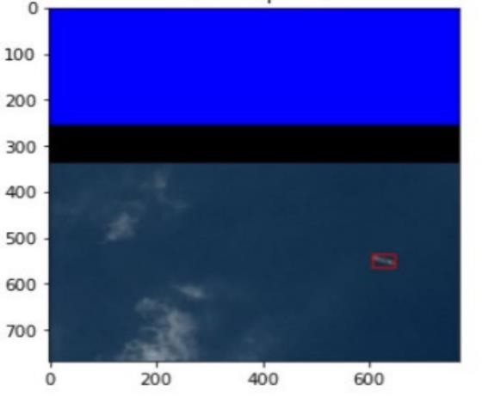The sophisticated Yolov3 algorithm allows us to identify even tiny ships, as the bounding area of the ship is greater than 1 percentile so that it is not dropped.

Fig 13: Describes how small sized ships are identified.

Next step we have tried to count the no.of ships that are in the image. The algorithm is further extended to count ships that are in the image.

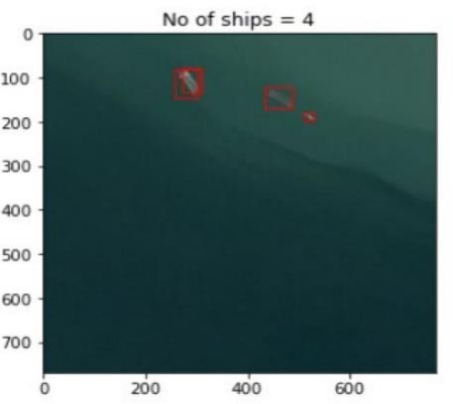

Fig 14: How the ships are counted and displayed on the

top of the image.

With the help of count function and formator we are able to display the no. of ships on the image.

The implementation of hashing is done numerous real time applications, where locating missing ships and preventing trafficking of illicit commodities. After the satellites have first gathered the Synthetic Aperture Radar (SAR) images, they forward them to the relevant authority. We must use the safest and strongest algorithm, such as SHA-512, to protect the data.

So, we can observe how the hashing is shown below picture. In order to depict the hash value, we have used the hashlib encoding algorithm from SHA-512 library, which provides the ships' placements and their value as a count. One of the safest and most difficult to crack algorithms, the SHA-512 algorithm, is used to generate the hashing value. Using a brutef force strategy, it would take 2^256 time to –decode the hash value without the key.

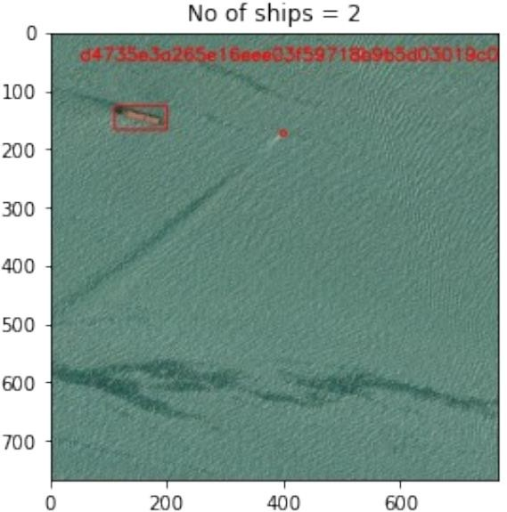

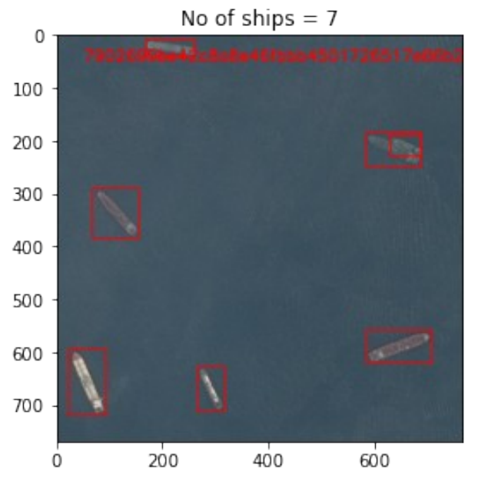

Fig 15: Hashing Value along with Count of ships.

Since hashing is unique and irreversible, it is desirable to utilize it with the model. Since all of the SAR data originates from satellites and is initially centralized, it might become a potential target and be readily attacked if security mechanisms are not implemented to safeguard it. Thus, to guarantee secure data, effective algorithms are employed.

Additionally, this can used in other domains, such as tracking ships and locating lost ships, among others.

In order to understand whether the developed algorithm works fine for the multiple images or not we have checked it by passing multiple images. The input to the algorithm is given dynamically so that the algorithm works accurately and efficiently.

The following diagram depicts the output of the images which are passed to the algorithm at a time.

. 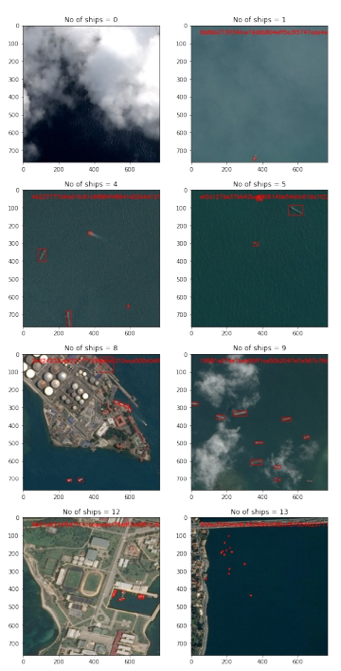

Fig 16: Shows how the algorithm works when there are multiple ships.

In order to check whether the model is working correct or not the integrity check is done.

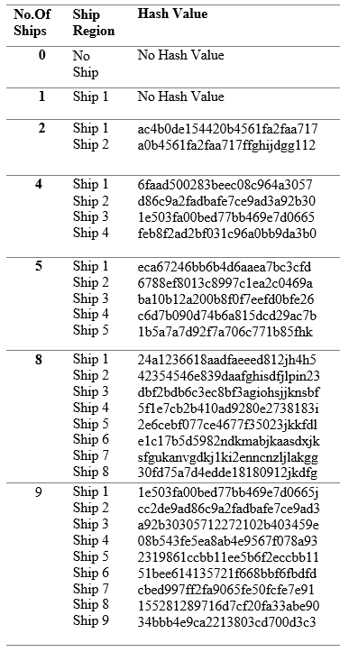

Table 3: Integrity Check for Hash Value.

## 4. CONCLUSION AND FUTURE SCOPE

In this paper a secure and enhanced way for identifying of ships using the deep learning approach has been done, the data which we have performed operations is all real time data and with this we can say that it works accurately for any type of images like cloud, land masked and high resolution, over any climatic data. By the utilization of YOLOV3 algorithm and its multilevel feature extraction and identification helps us to detect the images at three levels which are small, medium and large. And the rel2bbox help us to identify the area where the ships are present which can be located by looking at the rectangular box.[14]

Normalization has been done in order to remove the duplicate values and also for the bounding box area which less than 1 percent so that the accuracy and effectiveness is improved and processed time also reduced.

Furthermore, this model is also works for the user data if the user gives the input of images and the backend code will process and gives the output as it is required. The usage of SHA-512 algorithm gives the integrity and security to the loc of the ship and count of the ships so that they remain confidential.

In Future this model is proposed to work for the video

input frames also.

## REFERENCES

Nie, X. et.al [1], Yang, M., & Liu, R. W. Deep neural network-based robust ship detection under different weather conditions. In 2019 IEEE Intelligent Transportation Systems Conference (ITSC) (pp.47-52).IEEE. [<https://ieeexplore.ieee.org/abstract/document/8917475>] (2019, October).

Rong, H. et.al [2], Ramirez-Serrano, A., Guan, L., & Gao, Y. Image object extraction based on semantic detection and improved K-means algorithm. IEEE access, 8, 171129-171139. [<https://ieeexplore.ieee.org/abstract/document/9200601>] (2020).

Li, H. et.al [3], Deng, L., Yang, C., Liu, J., & Gu, Z. Enhanced YOLO v3 tiny network for real-time ship detection from visual image. Ieee Access, 9,16692-16706. [<https://ieeexplore.ieee.org/abstract/document/9334973>] (2021).

Wang, Y. et.al [4], Rajesh, G., Mercilin Raajini, X., Kritika, N., Kavinkumar, A., & Shah, S. B. H. Machine learning-based ship detection and tracking using satellite images for maritime surveillance. Journal of Ambient Intelligence and Smart Environments, 13(5), 361-371.[<https://content.iospress.com/articles/journal-of-ambient-intelligence-and-smart-environments/ais210610>] (2021).

Hong et.al [5], Z. et.al, Yang, T., Tong, X., Zhang, Y., Jiang, S., Zhou, R., ... & Liu, S. Multi-scale ship detection from SAR and optical imagery via a more accurate YOLOv3. IEEE Journal of Selected Topics in Applied Earth Observations and Remote Sensing, 14, 6083-6101. [<https://ieeexplore.ieee.org/abstract/document/9448440>] (2021).

Gadamsetty, S. et.al [6], Ch, R., Ch, A., Iwendi, C., & Gadekallu, T. R. Hash-based deep learning approach for remote sensing satellite imagery detection. Water, 14(5), 707.

https://www.mdpi.com/2073-4441/14/5/707] (2022).

Nie, X. et.al [7], Duan, M., Ding, H., Hu, B., & Wong, E. K. Attention mask R-CNN for ship detection and segmentation from remote sensing images. Ieee Access, *8*, 9325-9334. [<https://ieeexplore.ieee.org/abstract/document/8951182>] (2020).

Van de Sande, K. E. et.al [8], Uijlings, J. R., Gevers, T., & Smeulders, A. W. Segmentation as selective search for object recognition. In 2011 international conference on computer vision (pp. 1879-1886). IEEE. [<https://ieeexplore.ieee.org/abstract/document/6126456>] (2011, November).

Hannevik, T. N. et.al [9], Olsen, Ø., Skauen, A. N., & Olsen, R. Ship detection using high resolution satellite imagery and space-based AIS. In 2010 International WaterSide Security Conference (pp. 1-6). IEEE.[<https://ieeexplore.ieee.org/abstract/document/5730248>] (2010, November).

Zou, L. et.al [10], Zhang, H., Wang, C., Wu, F., & Gu, F. Mw-acgan: Generating multiscale high-resolution SAR images for ship detection. Sensors, 20(22), 6673.

Chen, X. et.al [11], Xiang, S., Liu, C. L., & Pan, C. H. Aircraft detection by deep belief nets. In 2013 2nd IAPR (2020). [<https://www.mdpi.com/1424-8220/20/22/6673>]

Asian Conference on Pattern Recognition (pp. 54-58).IEEE.

[<https://ieeexplore.ieee.org/abstract/document/6778281>] (2013, November).

Redmon, J. et.al [12], Divvala, S., Girshick, R., & Farhadi, A. You only look once: Unified, real-time object detection. In Proceedings of the IEEE conference on computer vision and pattern recognition (pp. 779-788).[<https://www.cv-foundation.org/openaccess/content_cvpr_2016/html/Redmon_You_Only_Look_CVPR_2016_paper.html>] (2016).

Zhao, K. et.al [13], & Ren, X. Small aircraft detection in remote sensing images based on YOLOv3. In IOP Conference Series: Materials Science and Engineering (Vol. 533, No. 1, p. 012056). IOP Publishing. [<https://iopscience.iop.org/article/10.1088/1757-899X/533/1/012056/meta>]. (2019, May)

Ying et.al [14], R. Airport and Ship Target Detection on Satellite Images Based on YOLO V3 Network. In Proceedings of the 6th China High Resolution Earth Observation Conference (CHREOC 2019) (pp. 167-174). Springer Singapore. [<https://link.springer.com/chapter/10.1007/978-981-15-3947-3_12>] (2020).

Nie, X. et.al [15], Liu, W., & Wu, W. Ship detection based on enhanced YOLOv3 under complex environments. Journal of Computer Applications, 40(9), 2561. [<http://www.joca.cn/EN/10.11772/j.issn.1001-9081.2020010097>] (2020).

Chang, L et.al [16]., Chen, Y. T., Hung, M. H., Wang, J. H., & Chang, Y. L. Yolov3 based ship detection in visible and infrared images. In 2021 IEEE International Geoscience and Remote Sensing Symposium IGARSS (pp. 3549-3552). IEEE. [<https://ieeexplore.ieee.org/abstract/document/9555032>] (2021, July).

Zhu, M. et.al [17], Hu, G., Zhou, H., Lu, C., Zhang, Y., Yue, S., & Li, Y. Rapid ship detection in SAR images based on YOLOv3. In 2020 5th international conference on communication, image and signal processing (CCISP) (pp. 214-218). IEEE. [<https://ieeexplore.ieee.org/abstract/document/9273476>] (2020, November).

Wu, T. D. et.al [18], Wang, H. F., Hsu, P. H., Tiong, K. K., Chang, L. C., & Chang, C. H. Target Detection and

Recognition in Synthetic Aperture Radar Images Using

YOLO Deep Learning Methods. In 2023 International

Conference on Consumer Electronics-Taiwan (ICCE-

Taiwan) (pp.593-594).IEEE. [<https://ieeexplore.ieee.org/abstract/document/10226736>] (2023, July).

Guo, W. et.all [19], Wang, X., Lu, F., & Wang, H. Research on Intelligent Transportation Based on'you only look at once at image'algorithm: Taking the crackdown on prostitutes' nests as an example. In 2022 International Conference on Big Data, Information and Computer Network (BDICN) (pp. 231-234). IEEE. [<https://ieeexplore.ieee.org/abstract/document/9758498>] (2022, January).

Bhattacharya, S. et.al [20], Maddikunta, P. K. R., Hakak, S., Khan, W. Z., Bashir, A. K., Jolfaei, A., & Tariq, U. Antlion re-sampling based deep neural network model for classification of imbalanced multimodal stroke dataset. Multimedia Tools and Applications, 1-25. [<https://link.springer.com/article/10.1007/s11042-020-09988-y>] (2020).

Gadekallu, T. R. et.al[21], Alazab, M., Kaluri, R., Maddikunta, P. K. R., Bhattacharya, S., & Lakshmanna, K. Hand gesture classification using a novel CNN-crow search algorithm. Complex & Intelligent Systems, 7, 1855-1868. [<https://link.springer.com/article/10.1007/s40747-021-00324-x>] (2021).

Srinivasu, P. N. et.al [22], Bhoi, A. K., Jhaveri, R. H., Reddy, G. T., & Bilal, M. Probabilistic deep Q network for real-time path planning in censorious robotic procedures using force sensors. Journal of Real-Time Image Processing, 18(5),1773-1785. [<https://link.springer.com/article/10.1007/s11554-021-01122-x>] (2021).

Qi, L. et.al [23], Li, B., Chen, L., Wang, W., Dong, L., Jia, X., ... & Wang, D. Ship target detection algorithm based on improved faster R-CNN. Electronics, 8(9),959. [<https://www.mdpi.com/2079-9292/8/9/959>] (2019).

Bhonge, H. N. et.al [24], Ambat, M. K., & Chandavarkar, B. R. An experimental evaluation of SHA-512 for different modes of operation. In 2020 11th International Conference on Computing, Communication and Networking Technologies (ICCCNT) (pp. 1-6). IEEE. [<https://www.researchgate.net/publication/346942868_An_Experimental_Evaluation_of_SHA-512_for_Different_Modes_of_Operation>] (2020, July).